(Hidaya School)

Dearest Brothers and Sisters,
Assalamu- Aleykum!
El-Zahra Foundation Inc., was registered in the State of New Jersey in May 1997 as a nonprofit religious educational organization serving the Muslim community of the Metropolitan Area. Since its inception, it has been involved in the following aims and objectives.
- Help meet the religious, educational, social and cultural needs of the Muslim community, via the Hidaya Weekend School (Saturday and Sunday)
- Provide facility and resources for the up bringing of Muslim children as true practicing and productive Muslims, as law abiding US citizens and great human beings
- Uplift the spiritual, social and civic consciousness of Muslims via Mawlid Programs, religious celebrations, invitations of international scholars and participation in outreach programs that promote peace and environmental awareness.
- Reach out to other faiths with the purpose of providing an understanding of Islam and promoting mutual respect via various interfaith dialogues and activities.
- Promote harmony between people of different Faiths, Ethnic backgrounds and national origins
- Provide material and moral help and support to needy, irrespective of race or religion
- Provide services to the community including, birth, marital, funeral, and regular meetings which increase spirituality as well as dawah classes to new converts.
- Be respective to the changing needs of the community
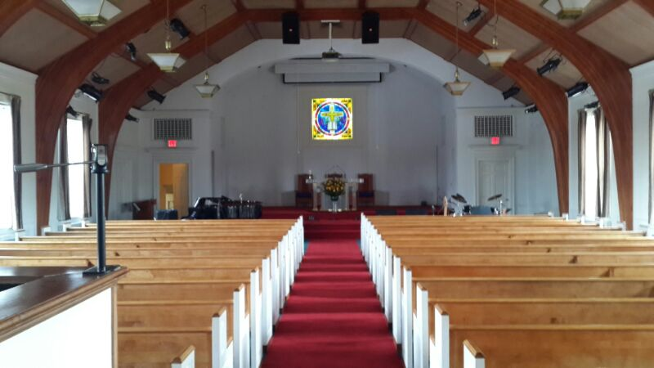
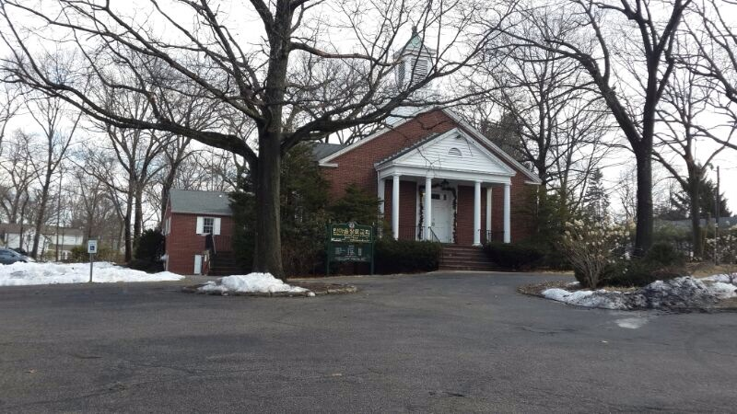

Want to make an impact?
Please fill out the pledge form below so that El-Zahra Foundation Inc. can further expand its services in the community and consolidate and expand its many activities. Presently, we are in the process of acquiring a Church to become our Islamic and Community Center at 218 Irving St, Midland Park, NJ. We are in great need of your donations at this time. The total cost of the building is 2.130 million dollars. May Allah (SWT) guide, bless, and protect you and your families always.
Jazak-Allah!
Sheikh Mohammad Moutaz Charaf
President and Founder of El-Zahra Education Foundation
------------------------------------------------------------------------------------------------------------------------------

(Hidaya School)
First Name: ______________________ Last Name __________________________
Address: ________________________ City______________ State _____ Zip ________
Home Phone: ( ) _________________________ Cell Phone: __________________
Email: _____________________________________________________

Please select your desired contribution:

- Enclosed is my donation of:  $10,000  $5,000  $2,000  $1,000  $500
 Other: $ ________
2. Monthly Pledge $ __________________ Start Month/Year: _____________
 Cash
 Credit Card (Circle One) MC VISA AMEX DISCOVER
Card # ____/_____/_____/_____ Exp Date: ______/_____
 Check
 Bank Withdrawal Name of Bank: ____________________________
Banking Routing No: _____________________ Account No: _______________
Your Donation is tax deductible. Our Tax ID# 22-3516796
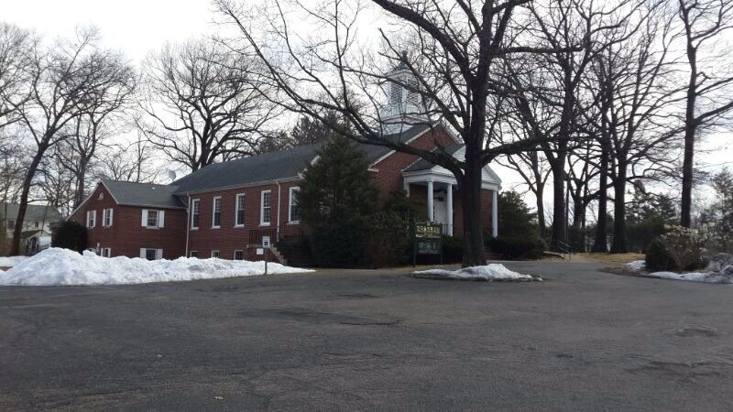
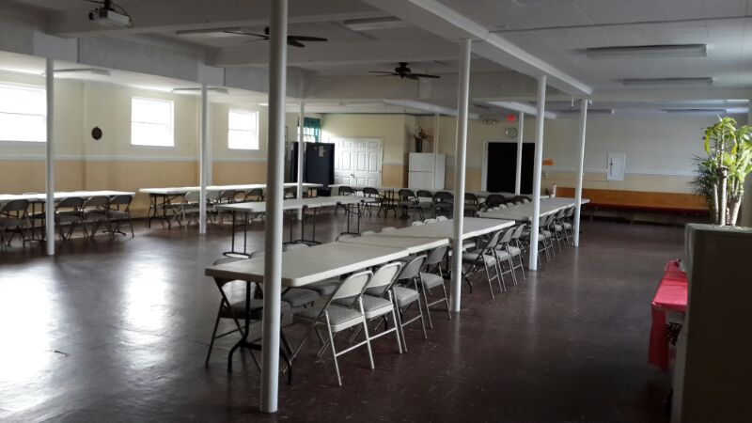
El-Zahra Education Foundation
P.O 2097
Teaneck New Jersey 07666
For inquiries call 201-675-0516
www.elzahra.org

